SCM Notes | Session 5: SC Processes — Manufacturing KPIs, Inventory, Distribution & Customer Service
Course: Supply Chain Digitization

1. Process 3 (contd.) — Production & Manufacturing KPIs

3 Types of Capacity — Definitions
- Design Capacity: maximum capacity the system is available to operate at (ideal/theoretical maximum)
- Effective Capacity: Design Capacity minus planned unavailability (e.g. preventive maintenance, setups, changeovers)
- Actual Capacity (Actual Output): Effective Capacity minus unplanned unavailability (e.g. machine breakdowns, spare part shortages)

Utilisation & Efficiency — Formulas
- Utilisation = Actual Output ÷ Design Capacity (what % of max theoretical (or design) capacity is achieved)
- Efficiency = Actual Output ÷ Effective Capacity (what % of planned usable (or effective) capacity is achieved)
- Numerator is same (Actual Output); denominator differs

Worked Example — Leather Bag Manufacturer
- Given data:
- Actual output (last week) = 1,02,000 bags
- Effective capacity = 1,07,500 bags
- Working schedule = 7 days/week × 2 shifts/day × 9 hrs/shift
- Production rate = 900 bags/hour
- Step 1 — Calculate Design Capacity:
- Design Capacity = 7 days × 2 shifts × 9 hrs × 900 bags/hr = 1,13,400 bags
- Step 2 — Utilisation:
- 1,02,000 ÷ 1,13,400 = 89.9%
- Step 3 — Efficiency:
- 1,02,000 ÷ 1,07,500 = 94.8%
- Other production KPIs (from Session 4): OEE, Cycle Time, Throughput, Capacity Utilisation

2. Process 4 — Inventory Management
- Def: knowing how much product is available on hand and where it is located → enables SC decision-making
- Goal: balance between adequate stock on hand AND avoiding surplus/hoarding

Inventory Management Techniques
- ABC Analysis: classify products into A, B, C categories by importance/value; most widely used technique
- Safety Stock: buffer stock based on lead time & lead time variability to cover demand uncertainty
- EOQ (Economic Order Quantity): balances ordering cost vs. holding cost to find optimal order quantity
- Reorder Point: triggers replenishment order to ensure product is always available when needed

Inventory KPIs — Formulas
KPI | Formula | What it tells you
Average Inventory | (Beginning Inv. + Ending Inv.) ÷ 2 | Avg stock held over a period
Inventory Turnover Ratio | COGS ÷ Average Inventory | How many times inventory is sold/used per year; higher = faster moving
Inventory Turnover Rate (Days) | Period (days) ÷ Turnover Ratio | No. of days to sell/use all inventory; lower = faster
Stockout Rate | Frequency & duration of inventory shortages | Tracks lost sales & customer dissatisfaction
Inventory Carrying Cost | Storage + Insurance + Labour + other holding costs | Total cost of holding inventory
Days of Inventory on Hand | (Avg Inventory ÷ COGS) × 365 | Days of stock available before running out

Worked Example — T-Shirt Boutique (Inventory Turnover)
- Planning period: 1 quarter = 90 days | COGS = ₹15,00,000 (same for both scenarios)
Scenario | Avg Inventory | Turnover Ratio (COGS ÷ Avg Inv.) | Turnover Rate (90 ÷ Ratio) = Days
1 — Lower Avg Inventory (₹1,50,000) | ₹1,50,000 | 15,00,000 ÷ 1,50,000 = 10 | 90 ÷ 10 = 9 days
2 — Higher Avg Inventory (₹5,00,000) | ₹5,00,000 | 15,00,000 ÷ 5,00,000 = 3 | 90 ÷ 3 = 30 days
Interpretation:
- Scenario 1 (low inventory): turnover ratio = 10 (faster), rate = 9 days → refill needed more frequently → more responsive
- Scenario 2 (high inventory): turnover ratio = 3 (slower), rate = 30 days → refill less frequently → higher holding cost
- Key insight: use these KPIs to decide the right inventory level — avoid missing demand while minimising holding cost

3. Process 5 — Distribution & Logistics
- Role: ensure product is available to customer as per their requirement; coordinate order mgmt → warehousing → inventory mgmt → transportation
- Customer expectation: real-time order visibility and ability to track shipment

Role of Data Analytics in Distribution & Logistics
- Route optimisation: analyse historical traffic + weather data → optimise delivery routes in real time
- Warehouse optimisation: space utilisation, product placement decisions, picking process efficiency
- Fleet optimisation: vehicle routing, fuel consumption, maintenance scheduling, reducing operational cost
- Inventory optimisation: right stock at right location
- Real-time visibility: tracking orders through the distribution network

Decisions Enabled by Digitisation
- Type of SC network design (suitable for fulfilment requirement)
- Mode of transportation selection → down to specific vehicle type

Distribution & Logistics KPIs
- Transportation Cost per Unit
- Order Cycle Time
- On-Time Delivery (OTD)
- Inventory Turnover Rate
- OTIF (On-Time In-Full): both delivered on time AND in correct quantity

Worked Example — 3PL Selection (Total Cost Analysis)
- Context: company choosing between 2 logistics providers (Avitruck & Logitruck) for 3 product types (Modern, Semi-Modern, Classical)
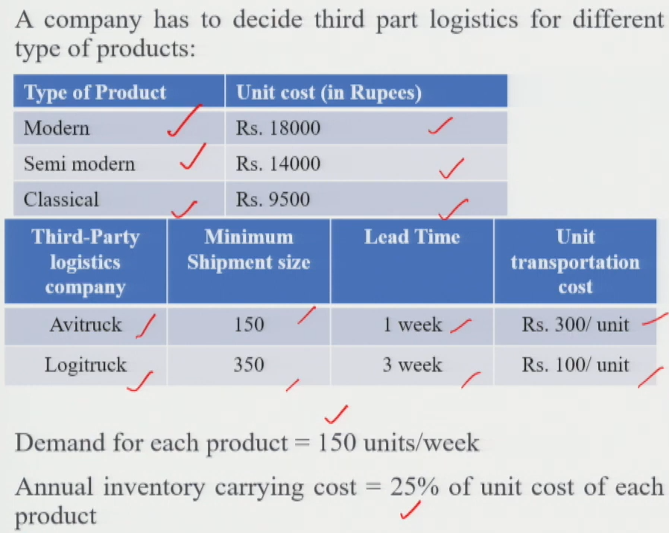
- Total Cost = Annual Inventory Carrying Cost + Annual Transportation Cost
- Key terms used:
- Cycle Stock: = 0.5 × Shipment Size (average inventory from one order cycle)
- Pipeline Inventory: = Lead Time × Demand Rate (stock in transit)
- Total Inventory: = Cycle Stock + Pipeline Inventory
- Annual Carrying Cost: = Total Inventory × Unit Cost × 25%
- Annual Transport Cost: = Annual Demand (weekly demand × 52) × Transport Cost/unit
- Sample calculation (Logitruck + Modern product):
- Shipment size = 350 → Cycle Stock = 0.5 × 350 = 175 units
- Lead time = 3 wks, Demand = 150 units/wk → Pipeline Inv. = 3 × 150 = 450 units
- Total Inventory = 175 + 450 = 625 units
- Annual inventory carrying cost = 625 x 18000 x 0.25 =₹ 28,12,500
- Transport Cost = 150 × 52 × ₹100 = ₹7,80,000/year
- Total Cost ≈ ₹35,92,500
- Result (all combinations analysed):
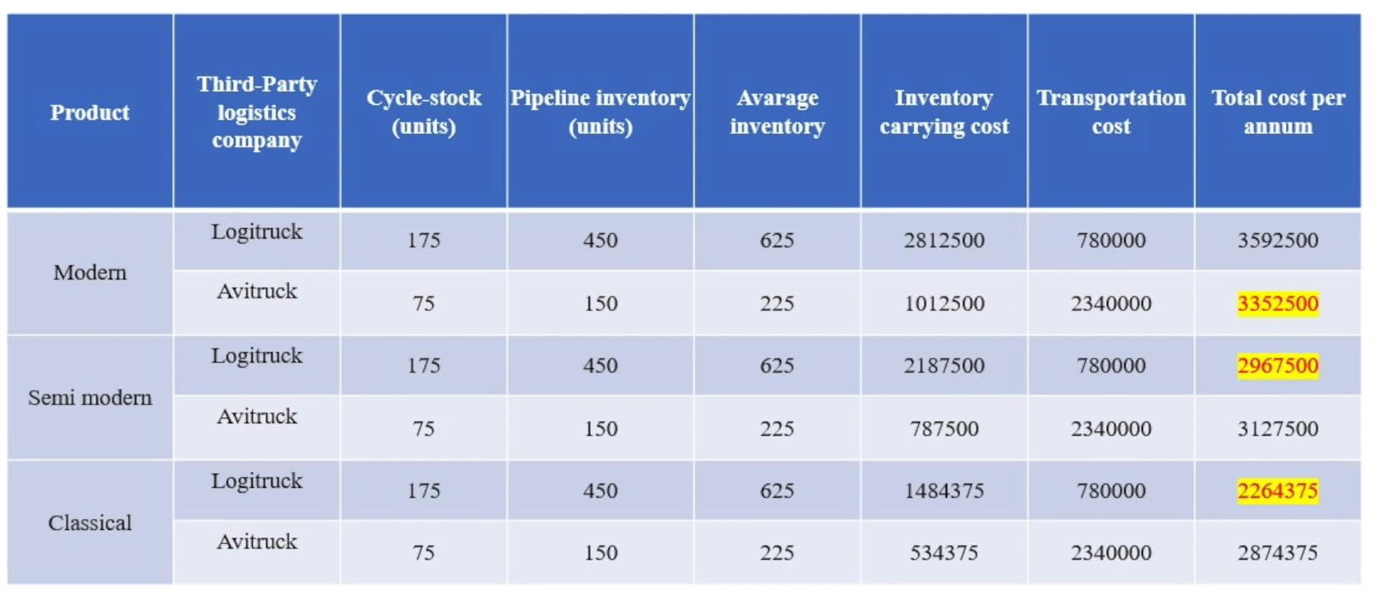
- Modern product → Avitruck (lower total cost)
- Semi-Modern product → Logitruck (lower total cost)
- Classical product → Logitruck (lower total cost)

4. Process 6 — Customer Service
- Role: drives the whole SC; focuses on providing support to customers throughout their experience
- 3 core customer expectations:
- Effective communication: real-time order tracking & visibility
- Responsiveness: fast responses to queries and issues
- Quality: consistently high product and service quality

Scope of Digitisation in Customer Service
- Improved inventory mgmt → faster response times → more customers attracted
- Order tracking → transparency & visibility for customer
- Reverse logistics: returns, refunds, exchanges managed efficiently via digitised systems

Customer Service KPIs — Definitions
- Order Fulfilment Cycle Time: time from order placement to delivery
- On-Time Delivery (OTD): % of orders delivered on or before promised date
- Fill Rate: % of customer demand fulfilled immediately from stock — no backorders, no delays
- Return Rate: % of products returned by customers; critical in e-commerce; efficient processing = better experience
- Supplier On-Time Delivery Rate: % of times supplier delivers RM on time (tracks supplier performance)
- Compliance with SLAs: adherence to agreed service level agreements

Worked Example — Soap Bar Manufacturer
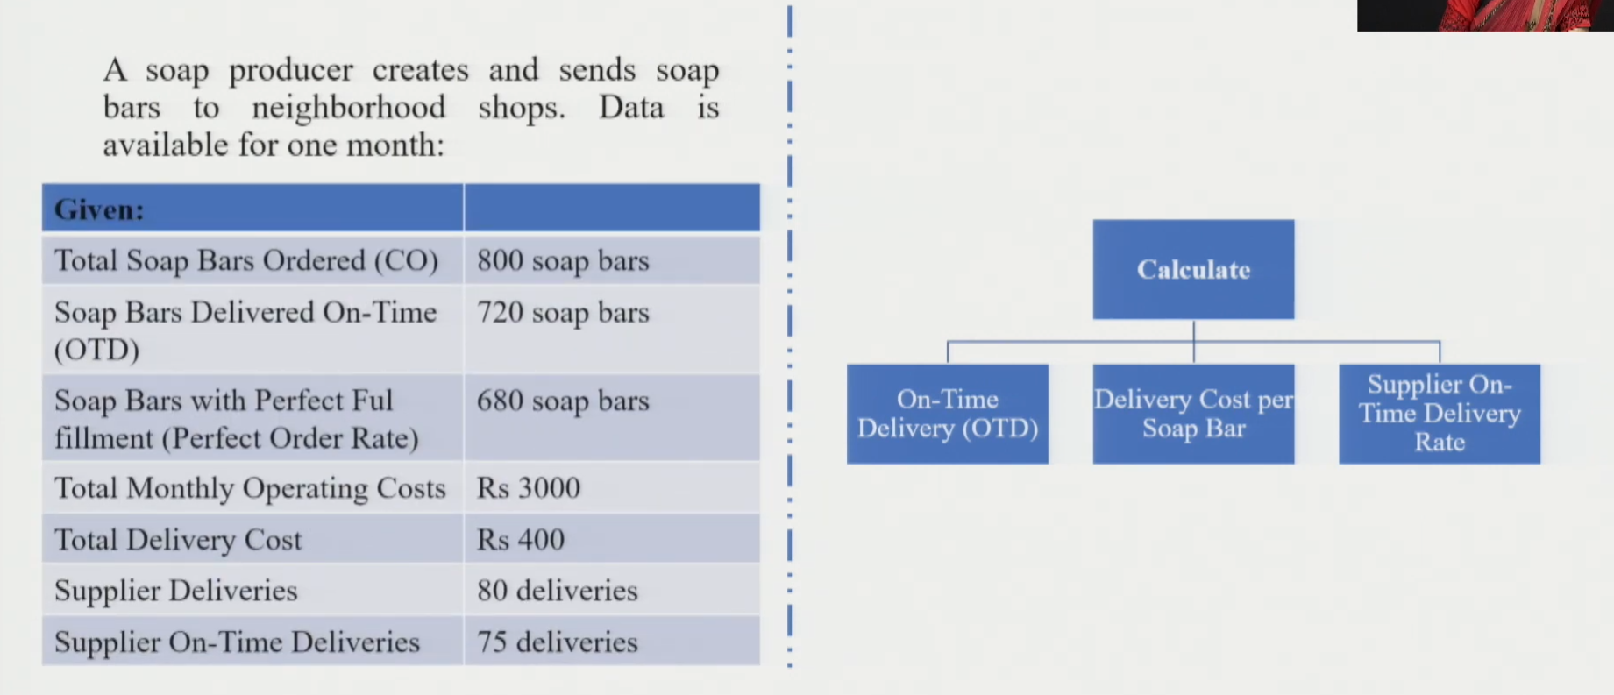
- KPI 1 — On-Time Delivery:
- Formula: (Soap bars delivered on time(720) ÷ Total soap bars ordered(800)) × 100
- Result: 90% → 90% of orders delivered on or before promised date → excellent performance
- KPI 2 — Delivery Cost per Soap Bar:
- Formula: Total Delivery Cost (400) ÷ Total Soap Bars Delivered(720)
- Result: ₹0.56 per soap bar → shipping fee per unit; useful to compare across logistics options
- KPI 3 — Supplier On-Time Delivery Rate:
- Formula: Supplier On-Time Deliveries(75) ÷ Total Deliveries by Supplier(80)
- Result: 93.75% → suppliers deliver RM on time 93.75% of the time → good supplier performance

5. Module 1 — Full Summary Table (All 6 SC Processes)
Process | Core Goal | Key Techniques | Key KPIs
Planning & Forecasting | Predict demand; plan resources, capacity & network | Moving Avg, Regression, AI/ML | MAPE, MAD, MSE, RMSE, Bias, R²
Sourcing & Procurement | Right suppliers at right cost; end-to-end acquisition | Supplier evaluation, Kraljic Matrix | Supplier score, Lead time, PO cycle time, PO accuracy, Compliance
Production & Manufacturing | Convert RM to FG efficiently | SPC, ML, Predictive Maintenance | OEE, Cycle Time, Throughput, Utilisation (89.9%), Efficiency (94.8%)
Inventory Management | Balance stock availability vs. holding cost | ABC Analysis, Safety Stock, EOQ, Reorder Point | Avg Inventory, Turnover Ratio, Turnover Rate, Stockout Rate, Carrying Cost, Days on Hand
Distribution & Logistics | Make product available to customer efficiently | Route/fleet/warehouse optimisation, 3PL cost analysis | Transport cost/unit, Order cycle time, OTD, Turnover rate, OTIF
Customer Service | Support customer; ensure satisfaction & loyalty | Real-time tracking, reverse logistics systems | Fulfilment cycle time, OTD, Fill rate, Return rate, Supplier OTD, SLA compliance
✓ Exam Angle: "Describe all 6 SC processes with their KPIs and role of digitisation." → Use the summary table above. For numerical questions: be ready to compute Utilisation/Efficiency (capacity formulas), Inventory Turnover Ratio/Rate, 3PL total cost, OTD rate, and delivery cost per unit.
★ End of Module 1 — Next: Module 2 on Supply Chain Segmentation

